EX ALDERMAN NEWSLETTER 8
OCTOBER 3, 2010
FROM: John Hoffmann

PROMPTNESS DOESN’T COUNT: One might think that promptness is good in politics, particularly when you only meet twice a month. But that is not the case in Town and Country. The work session meetings rarely start on time. Last Monday’s meeting was scheduled for 6:30 with the regular Board of Aldermen meeting set to start at 7pm. Here is the attendance timeline for that meeting:
6:30 Aldermen Welby and Gerber were in the meeting room with Alderman Phil Behnen walking through the door.
6:34 Mayor/Cigarette Lobbyist Dalton and Alderwoman Wright arrived.
6:35 Alderman Steve Fons decided to show up.
6:38 Dalton started the meeting 8 minutes late.
6:41 Alderman Fred Meyland-Smith arrived.
Alderman David Karney and Alderwoman Nancy Avioli didn’t show up at all for the work session or the regular meeting. (nancy has missed 30% of the meetings so far this term.)
BUILDING RENOVATION AT T&C CROSSING: Gosh…they just opened the place and want to renovate already. The reason for the renovation was they never could find a large enough tenant for the “L” building on the northwest end of the shopping center and now want to split the building up for smaller tenants. As reported in the last newsletter the developer plans to rip out rear walls and install doors and plate glass windows.
After the presentation, Fred Meyland-Smith did what is known in the business as a “stroke job” to Ted Levin, one of the developers. Thanking him for allowing the city to use the shopping city for the fireworks show.
Well of course they wanted to host the fireworks show! Their tenants are desperate to get people to come to their stores. The rental rates for this center have been so high that they have not completed building the entire center…so there is plenty of room and a need. Ted should be thanking the city!
CITY TAX RATE STAYS AT ZERO: The Board of Aldermen voted to keep the tax rate at zero.
ESTATE SALES: The bill concerning estate sale regulations that would give the police chief and ability to reject applications was continued…Because Alderwomen Avioli was not present.
At the meeting on September 13 Alderman Phil Behnen said a $5 fee proposed in the bill (same as current fee) is not realistic. Phil did not indicate if he thought it should be eliminated or raised.
At this meeting City Administrator John Copeland reported City Clerk Pam Burdt did a telephone survey of other nearby towns and found 11 out of 14 cities charged NOTHING for estate sale/garage sale permits. For the ones that charged, the amounts were between $5 and $10.
Al Gerber asked if the time for the staff to handle and deposit the check wouldn’t be more than $5. It was a rhetorical question.
IN WARD THREE…NOT A CLUE: On the agenda for a final vote was a bill to extend the No Parking Zone on Arlington Oaks at Clayton from 30 feet from Clayton Road to 90 feet.
At the September 13th meeting it was explained that the subdivision board of trustees requested this ordinance. The police and the “rubber-stamp” police commission agreed and all property owners affected by the new No Parking regulation had been contacted and did not object.
Anyone who has ever driven out of Arlington Oaks is immediately aware that there are view obstructions looking both east and west along Clayton Road. The problem with cars being parked to close to the intersection is if you are exiting the subdivision and have to pass parked cars by driving on the wrong side of the street you could have traffic turning from Clayton Road headed right at you. The same is true for traffic turning from Clayton suddenly coming upon parked cars. Real NO BRAINERS! (In fairness part of the view obstruction was created by Arlington Oaks as their entrance monument and shrubbery is part of the problem.)
Fred and Steve wanted to speak with the trustees of the subdivision and asked to continue the bill, apparently both having severe short time memory losses. This caused Capt. Gary Holzer of the police department to jump up and reminded everyone all these issues were addressed at the last meeting. Despite the aldermen from Ward 3 best intentions to delay this bill it did pass.
TOO MUCH NOISE FROM THE PARK: A new bill was on the agenda for a first reading to make it a violation to have any music or other noise in a park above 90 decibels. Alderwoman Lynn Wright explained that there are still complaints from the Wheatfield Farm subdivision about noise from the park.
WHERE IN THE WORLD IS WARD-3? Steve Fons Needs Carmen San Diego’s Help: Ward 3 Alderman Steve Fons then asked if the Wheatfield Farm subdivision was next to Mason Ridge School, where some school activities create noise.
Unbelievable that Fons asked where the Wheatfield subdivision is! It is one of the bigger subdivisions in Ward 3 and its residents were the primary force behind the protests of any possible rezoning of the Principia property. How did Fons get re-elected?

LESS POLICE OFFICERS FOR 2011? On January 1, 2010 the police department laid off one of their best dispatchers and a recently promoted records clerk. At the same time a sergeant retired. Despite the city operating with a budget deficit his position was replaced.
Now the rumors according to current and former police officers and a local police message board say at least two police officer positions will be eliminated in 2011. This is in addition to the two dispatchers who will lose their jobs through the police dispatch consolidation with Creve Coeur and Frontenac.
Last January Mayor/Cigarette Lobbyist Jon Dalton and City Administrator/Police Chief John Copeland said the two layoffs in the police department would not be noticed.
If the two-officer layoffs occur in three months happen it will be interesting if Mayor Dalton and Chief Copeland try and claim further reductions in the police department will also go unnoticed.
However, this from the Finance Committee...there has been no discussion of eliminating police positions.
Meanwhile as the police got downsized in 2010 Mayor Dalton was sure to leave money in the 2010 budget for fireworks.
Last week Chesterfield laid off seven police officers, including a captain and a lieutenant. It was part of 17 eliminated city jobs. After the Chesterfield Police firings, rumors of two layoffs in T&C began again. I am betting if there are layoffs it will be like last year when the proposed budget is released. There will be no mention of layoffs…just a reduction in employee salaries.
We hear that the staff is hoping a 32-year veteran sergeant retires. Last year a veteran sergeant retired, but instead of eliminating his position, the PD replaced him.
In Chesterfield Dalton’s mayor buddy John Nations (who is leaving in weeks to head Metro Transit) said the city was not downsizing, but “rightsizing.” This is completely bogus, Chesterfield might not be growing but it is not shrinking either. It is telling me that Nations allowed a bloated city payroll and was wasting tax monies if he wants to claim he is “rightsizing” by cutting 7-cops.
Dalton claimed the same thing this time last year when he laid off three employees. Again it was either a case of Dalton wasting tax money the year before or his failing to admit how bad this recession is going to affect city government.
PAVING OVER PARK LAND BEING CONSIDERED: The Parks Commission has been discussing doing an informal survey of park users about paving more park land at Longview Park for parking spaces.
We pointed out when we were first elected an alderman that Mayor Dalton spending $1.5 million for the Longview Farm House Conference Center addition was reckless and without a plan for parking.
Paid rental of the conference center has been almost non-existent this year. One of the problems has been a lack of parking and people using the facility have to provide valet parking during daylight hours.

BRANCH CHIPPING: In the public comment section at the beginning of the last Board of Aldermen meeting a resident criticized the city discontinuing branch chipping saying it was a service used by most residents and further criticized the city for not better notifying residents that branch chipping had been discontinued. He mentioned what I am sure several of us have noticed…stacks of branches in front of some houses.
Dalton took responsibility for not making better notifications. Keep in mind that branch chipping was cut from the budget by the finance committee in September of 2009 and remained cut when the budget was passed in December of 2009. Dalton kept his pet fireworks in the budget.

Late this summer several aldermen tried to override the judgment of the Board of Aldermen and put branch chipping back into the budget. It was much too late to do this, as contracts for fall chipping are normally issued in the spring.
Word from the finance committee is that branch chipping is still out of the budget for 2011.
I’VE GOT A SECRET! You would think that Mayor/Cigarette Lobbyist Jon Dalton was playing the part of Gary Moore because he kept mentioning that he had a big secret.
When a citizen complained about the city doing nothing to reduce highway noise…Dalton said the city was talking with MoDot and other State Officials about doing something about the highway noise problem. However, Dalton would give no details…A big secret!
The next secret involved the fire dispatching issue. As you may remember the Central Country Emergency 9-1-1 Dispatch Center dispatches all fire calls in T&C. We have been forced to continue to use CCE 9-1-1 by the contract that Dalton signed in 2005. It was just recently discovered by Dalton and others that CCE 9-1-1 was billing us on our property values and not by usage.
In fact we have been paying far more per the average cost of a call and were subsidizing people living the Creve Coeur, Maryland Heights, West County EMS, Metro West Fire Districts and two Franklin County ambulance districts.
Dalton said there have been two meetings with the Fire Dispatch people and he expects we will be given two options concerning dispatching payments. However he would not say what they were. I really wish he would keep his mouth shut until he actually has something to say or tell us what he knows.
A good example of this was on February 18th when Dalton announced at a neighborhood meeting how in two weeks he would announce the new tenant moving into the Wal-Mart store in Manchester Meadows. 236 days later we are still waiting for the two-week announcement from Dalton.
T&C TIME KEEPING: Dalton sets a good example for the rest of the staff. On June 14 Sharon Rothmel said she would announce the new tenant of the Wal Mart store in the next two months. 3 ½ months later still no announcement.
Public Works Director Craig Wilde in March of 2009 said by August of 2009 the new city Trash Ordinance would be in effect. One year and two months later it is still not in effect.
On June 1, 2009 Building Inspector Bob Bodley sent a letter to a developer giving him 30 days to resume building or return the property to a level lot after they had stopped construction for 1 ½ years. 30 days later nothing…60 days…nothing…182 days later they city took no action other than to send another threatening letter.
DEER UPDATE:
Accused of Deep Pockets: At the last Aldermanic meeting former Alderwoman Barbara Ann Hughes spoke during the public comment portion of the meeting concerning the private funding effort to kill deer. Hughes went after Alderwoman Lynn Wright and Fred-Meyland Smith.
“I am disappointed you got involved with the Lethal Deer Program. 61% of Ward 1 supported fertility methods to control deer,” she said.
“I am going to look at the board as a whole because you are encouraging people with deep pockets to dictate what goes on in Town and Country,” Hughes said. She then handed Meyland-Smith and Wright Sunshine Request letters demanding figures on what they have done for fundraising.
Wright and Meyland-Smith had said at the meetings they have attended asking for funds to raise $33,000 to kill deer that they were doing so as “citizens” and not alderpersons. Of course they both served in the positions as aldermen on all of the Deer Task Forces and one of the meetings was held at a city building…putting some of their efforts in a gray area.
NOT SO FAST: Mason Valley Estates trustee Chuck Lenz was at the meeting and got up to speak. Chuck said Barbara Ann’s comments about “deep pockets” being used to fund the effort were not true. He had been collecting money from Mason Valley residents and was getting checks from between $5 and $50.
MONEY FOR DEER SHOOT: With a goal of $33,000 to have two sharpshooters kill deer for a week; here are the totals as of September 27. The finance director said she had about $8,000 in checks for the lethal means plus $7,000 in pledges. (In the last newsletter we talked about how Fred’s friends were not writing checks like the rest of us, but were making “pledges.”) If you think all of Fred’s buddies will honor their pledges…there is also $5,000 in seed money from the budget plus $15,000 in contributions and pledges for $20,000 toward the goal of $33,000 for the sharpshooters.
So far exactly $200 has been received for the non-lethal deer control (sterilizations). The amount needed to do sterilizations is $66,000 or more.
If the non-lethal people cannot raise enough money to go to a program, the $5,000 seed money from the budget would transfer to the Lethal-fund…meaning that fund may have as much as $25,000 now.
The lack of contributions for non-lethal methods shows earlier demands from the deer-lover faction were hollow. Several people including Mrs. Hughes were coming to meetings asking for the city to allow residents to privately fund a sterilization program. Now that does not seem to have been a real option.

FOLLOW THE MONEY! How much are local lawmakers taking from lobbyists. State elected officials are paid $125 a day to attend sessions in Jefferson City. Keep in mind one of those days they actually drive home and have no overnight expenses. Hotel rooms in Jefferson City can be found for well under $100 a day. Days Inn in Jefferson City the room rate is $50 a night. Rooms are $76 a day at the Hampton Inn. It seems like that leaves plenty for food if a legislator wanted to avoid accepting gifts from lobbyists.

JOHN DIEHL: Mayor/Cigarette Lobbyist Jon Dalton’s good friend and his appointee to the Architectural Review Board, John Diehl accepted $1,318.55 in gifts so far in 2010. On 5-11-10 Diehl dined with lobbyist David Hale to a modest $198.60 meal. Clearly Mr. Diehl is not a fiscal conservative when it comes to eating. He had four other meals with Mr. Hale this year.
Mr. Hale’s only lobbying client is the Missouri Hospital Association. Ever wonder why your hospital bills are so high? Maybe it is because of the $200 diners being fed to state representatives.
AT&T lobbyist John Sondag treated Diehl to a $100 round of golf on May 24. That is cheap compared to last year when Diehl was treated to $211 and $149 rounds of golf.
Hospital and health insurance lobbyist Brent Evans has Diehl on the tab five times for meals.
SUE ALLEN: So far in 2010 Sue Allen, who was unopposed for reelection in both the primary and general elections, accepted just under $1,000 of free stuff from lobbyists in 2010, coming in with $966.58 in gifts. She was just over $1,000 last year. Sue has a background in medical treatment. She ran on a platform as being a “citizen legislator” wanting to represent the “Regular Joe.”
Her most expensive one time gift is $180 from Francis Flotron for dinner on February 10. My wife is from Jefferson City…I know that you really have to work hard to spend $50 on dinner in Cole County…let along $180! Sue is being quite a “citizen legislator”! The petite Rep. Allen must be eating at John Mineo’s, Napoli II and Annie Guns on a regular basis if she considers a $180 meal as normal for a regular Joe. Even then I don’t think she can rack up a $180 a meal unless she has a taste for vintage wine.
That might be the case when dining with Mr. Flotron, who lobbies medical insurance and health care plans, plus for the wine industry!
Sue accepted seven dinners from lobbyist Brent Evans, a flack for the Missouri Hospital Association, T-Mobile and cable industry giant Comcast.
When you think of the high costs of hospital stays and health insurance, think of Sue enjoying the highlife on the dime of the health insurance, hospital industries and even the tobacco industry.
Sue claims to be on the side the citizen, but she accepted a gift from John Bardgett, the lobbyist for Phillip Morris. Sue did nothing to increase the cigarette tax in Missouri (Missouri is 50th in the US in cigarette taxes) and further officially claimed there is no correlation between higher cigarette taxes and reductions in smoking. She also did nothing to ban the use of cell phones or even texting while driving.
SENATOR JANE CUNNINGHAM: Jane grabbed $1,494.68 in gifts from lobbyists. Cunningham along with Diehl and Allen accepted gifts from Missouri’s other top cigarette lobbyist (besides Jon Dalton of course), John Bardgett, who represents Phillip Morris. Bardgett gave Jane $110 in sporting tickets. Hale and Evans were also big gift givers to Jane.

A number of home schooled kids and their parents were treated to ice cream at Central Dairy in Jefferson City thanks to lobbyist Brent Evans. Do you think they thought Jane was giving them ice cream or a hospital industry lobbyist?

CARTOONS:
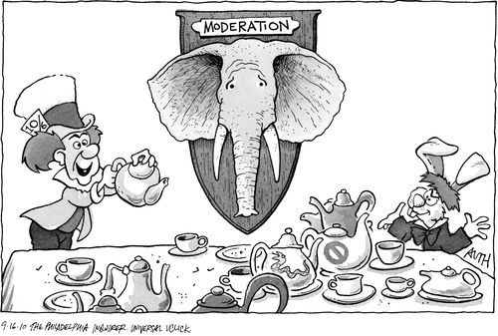


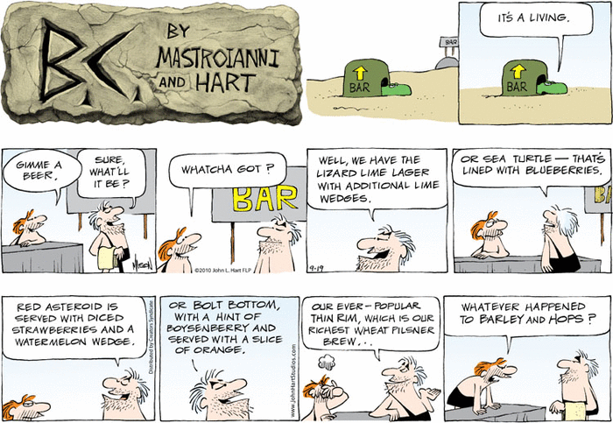

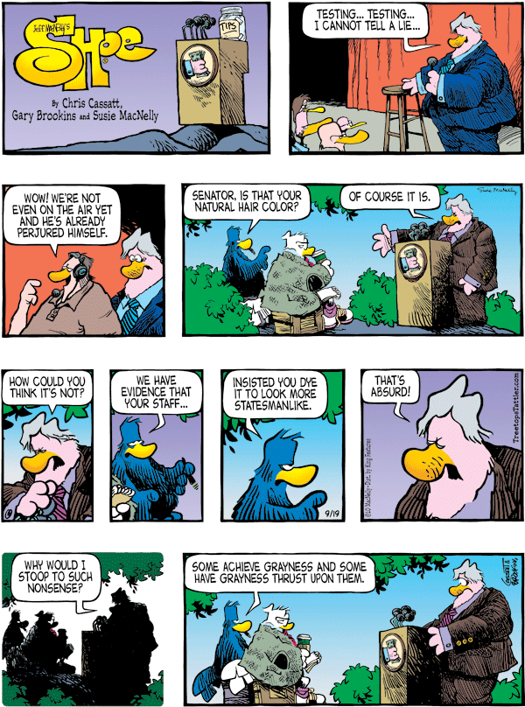
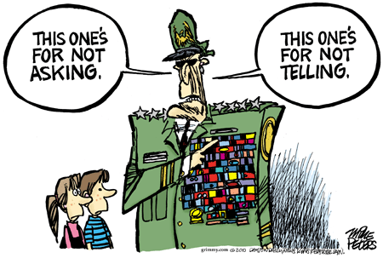

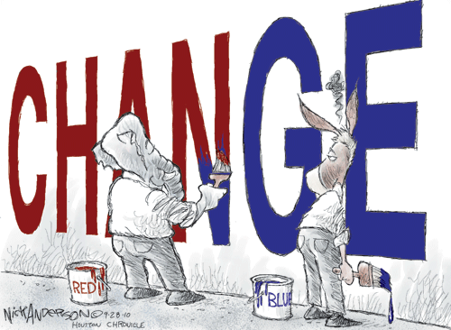

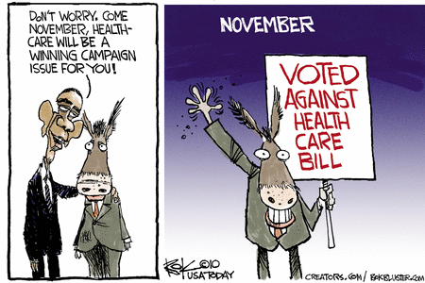
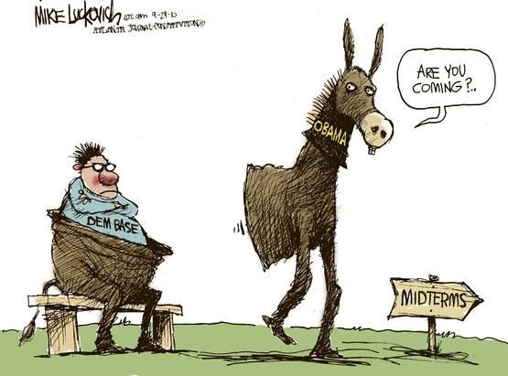


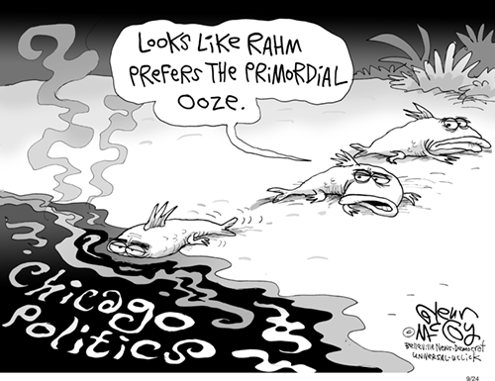

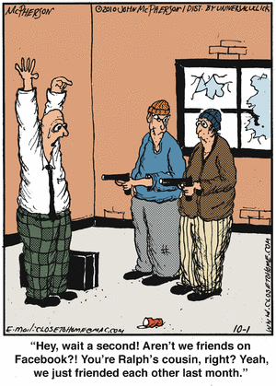
I

