EX ALDERMAN NEWSLETTER 40

December 13, 2011

By John Hoffmann

MAYOR DALTON COMPLAINS ABOUT COLUMN: In the last newsletter I wrote of the Missouri Court of Appeals affirming the $1,000,000 jury award against the St. Louis Land Authority. I also had mentioned how Town and Country Mayor Jon Dalton was a big player in the case. Dalton founded Ice House District Redevelopment LLC, with the intention of creating a nightclub district along South Broadway. I mentioned two other groups also involved apparently with Dalton..

Besides writing about this in Ex Alderman Newsletter #39, I write opinion columns for the Chesterfield Patch, an AOL website. One recent column was about how millionaires, including Dalton from West County were behind snatching private property. Even Dalton’s Law Firm Lewis-Rice was representing the St. Louis Land Authority in obtaining eminent domain against widow Opal Henderson’s salvage yard and other properties.

The column t appeared and ran for a week in the Chesterfield Patch. It was also picked up by the Ballwin-Ellisville Patch. The only comment on the column was a thank you from Opal Henderson’s grandson.

A week later the column was posted on the Town and Country-Manchester Patch website. It was up for about five hours when I got an email from an editor saying that Mayor Dalton was not happy with the column and claimed most of it was false.

By 1pm it was pulled and I was asked to rewrite it as the regional editor thought I was using too wide of a brush with my opinions. I rewrote the piece just using LLC filings, old news clips and court filings. In some ways the new version made Dalton look worse than the first one.
Top of Form



Opinion
- By John Hoffmann
- December 5, 2011
- Government,
- Opinion
- Widow Gets $1M For Junkyard Seized By Gov't
Despite an appeal on the case that has ties to West County investors, someone has to pay up.
The end of the line has come for a St. Louis condemnation case involving a woman named Opel Henderson, her 50-year-old downtown junkyard business and a handful of West County businessmen.
Now it appears someone is on the hook to pay Henderson a $1 million judgment, plus interest.
Henderson and her husband operated a salvage yard along South Broadway near downtown since 1947. After her husband died, her sons began working at the yard. Henderson paid property and business taxes plus she and her sons paid city earnings taxes.
As one might expect over the years while operating a salvage yard, they picked up a few code violation citations, but for the most part she was running a successful business.
In 2004, three limited liability corporations were formed that would appear to have some impact on Henderson’s life.
The Ice House District Redevelopment, LLC, was formed, involving Town and Country Mayor Jonathan Dalton. He was the registered agent and noted on his bio at the Lewis-Rice law firm that he was on the board of directors. Ice House’s address was the same as the law firm of Lewis-Rice where Dalton is a partner. The purpose of this LLC was to develop a nightclub area along South Broadway.
Papers creating the Brio Group, LLC, were filed with the Missouri Secretary of State in September 2004. Dalton was the resident agent and this company’s address was the same as Dalton’s law firm’s office. Dalton is a one-third partner in Brio.
A third LLC, French Market Development, was a 50-50 partner with Brio in the Ice House District Redevelopment group.
Also formed in 2004 was the Disper-Schmitt, LLC. The filing lists Daniel Schmitt of Naples, FL, as the organizer and Cindy Schmitt of St. Louis as the agent. In 2004, the same people behind Disper-Schmitt created Old Rock House, LLC. The Disper of Disper Schmitt is Gerald Mark Disper of Ballwin.
Limited liability corporation filings are different from regular corporation filings. With regular corporations, a listing of board members is required, as are the filings of annual reports. Nothing is required of LLCs other than a resident agent and an address. It can take some real detective work or court-ordered depositions to figure out who is who.
Immediately after forming as a LLC, Disper-Schmit bought property next to Henderson’s salvage yard with plans to open a bar.
All the LLC filings occurred at about the same time the City of St. Louis Board of Aldermen declared the area around Henderson’s salvage yard as “blighted.” The city’s land clearance authority appointed Ice House District Redevelopment, with Dalton as its agent, as the redeveloper for the area.
In 2006, the city moved to condemn Henderson’s property through the city’s Redevelopment Authority. Things get confusing as articles appear in the St. Louis Business Journal and the St. Louis Post-Dispatch claiming different persons are leading the redevelopment of the Ice House District. The Business Journal quoted Dan Schmitt as being “the principle developer” of the Ice House District, but also mentioned Dalton, Disper and realty company owner Mark Librach, who is from Creve Coeur.
Two months later, Jake Wagman of the Post-Dispatch wrote an article where Dalton is quoted as one of the developers. "There could be a bright future for this city and it doesn't include the continued operation of a junkyard," Dalton was quoted in the article.
By 2007, Henderson is represented by attorney Chet Pleban. They appeal the city condemnation of the property and the case goes to the Missouri Supreme Court. By this time, the city’s Redevelopment Authority is represented by Lewis-Rice, Dalton’s law firm.
Pleban claims all the West County development groups are behind the condemnation action against Henderson’s business. But the case was brought by the Redevelopment Authority.
The authority wins in the Supreme Court and Henderson loses her business. However, Pleban sues in St. Louis Circuit Court alleging her property was improperly and fraudulently taken through eminent domain at the hands of the city’s Redevelopment Authority.
In April 2010, the jury finds against the St. Louis Land Authority and for Henderson and awards her $1 million.
That verdict was appealed and in late November, the Court of Appeals upheld the $1 million verdict and tagged on $89,000 in interest penalties. A spokesperson for the city tells the Post-Dispatch that Disper-Schmitt is on the hook for the judgment. Who that exactly is I'm not sure. That's the trouble with LLCs.

Come on now, Jon Dalton is clearly the Simon Legree or Sidley Whiplash of this story. The bottom line of this is GREED and the use of eminent domain to take private property for a private enterprise.

This has to be a big embarrassment to Lewis-Rice. You wonder if Lewis-Rice isn’t considering getting rid of Dalton like Bryan-Cave did 10 years ago.

BOARD OF ALDERMEN NOW FORECASTING WEATHER…calling for a white Christmas: I don’t know what forecasts the Board of Aldermen and Director of Public Works Craig Wilde have been watching. Perhaps several of the alderpersons consider themselves meteorologists. But on Monday the board of aldermen voted to increase the money remaining in the snow removal budget by $50,000.

The justification for this reads, “Whereas heavy snow has been predicted for the month of December 2011.” The only mention of snow in the 10-day forecast is “partly sunny high 37 with a chance of snow showers on December 22. For all of 2012 we have budgeted just $150,000 for snow removal. So for the next 18 days, where there is only a slight chance of snow through December 23, they voted to add an amount that is a full one-third of the 2012 estimate for snow removal. It was amazing no one questioned this. I am guessing this means a White Christmas, per the mayor and aldermen.

I AM DREAMING OF A BLUE CHRISTMAS AGAIN! This is getting to be an annual event. Around Christmas time the Longview Farmhouse, built over 110 years ago, is the centerpiece of the Longview Farm Park suddenly has blue LED lights hanging off the trees in front of the house. This year the wreath and other greens on the porch are very attractive but are spoiled by the stupid LED Blue Lights.

The last few years I have told readers who is responsible for the lights. However I have received a letter from a well known divorce attorney threatening to sue me if I mention the person’s name again. I have attached the letter below. So if you want to know who is responsible for these ugly lights that ruin the charm of a 1900 farmhouse, please go to my website at http://johnhoffmann.net and check newsletters from last December.

.

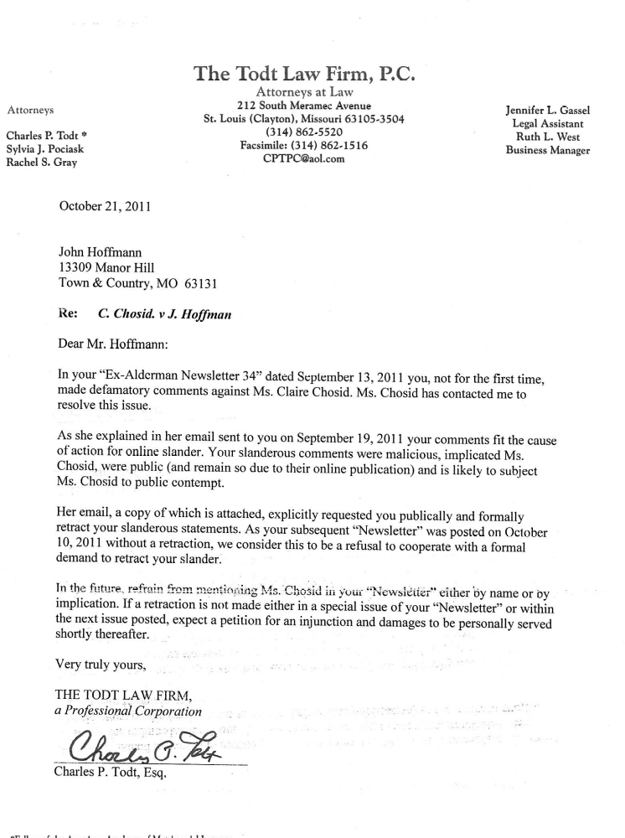
MAYOR DALTON, MEYLAND-SMITYH, FONS, GERBER AND WELBY…VOTE AGAINST BUSINESSES: Ward 2 alderman Tim Welby doesn’t like signs. Before Monday’s BOA meeting during the work session Welby said how he was not happy with the sign for Ginger Bay Spa that is on the building at Town and Country Crossing Shopping Center. “Compared to the other nearby signs it is to too big! I suggest you all go look at it,” said Welby

Nancy Avioli spoke up and said she had seen the sign and thought it looked great.

HI I’M RAY VINSON: On the agenda for was a public hearing for yet another variance from our not-so strict sign ordinance was TV pitchman Ray Vinson, who is moving his mortgage company to the office park off of Des Peres Road along I-270, south of the MAC and the Greek Church.

Vinson wants to have his sign on the building and wants a variance so the letters on the sign for the word “Vinson” can be 36 inches high while the letters on “Mortgage Group” will be only 26 inches high. However, they submitted a PLAN B for the “Vinson” letters to only be 30 inches high if the board refused to approve the 36 inch high letters.

There are plenty of businesses, hospitals and schools in town with letters on signs 36 or even 42 inches high.

There are now three businesses along 270 or I-64 that need easy to spot signs because of all the people that come to the buildings. Missouri Baptist Hospital is one. AAA or the Auto Club of Missouri is the second. They have a large insurance sales operation, a huge travel department and a drive in claims center.

Vinson Mortgage will be the other one. There are not going to be a lot of people in Town and Country getting Vinson mortgages. But there will be a whole lot of people coming from Afton, Lemay, Mehlville, Hazelwood and Bridgeton. The Town and Country location is centrally located. However, people coming to close on mortgages need to easily spot the building. It is almost a public safety issue. You don’t want them on Des Peres Road driving at 25 MPH trying to find street signs and taking their eyes off the road looking for signs. This guy ought to have sign the same size as other businesses..

Nancy Avioli and Lynn Wright both represent Ward-1 where the sign would be located. They were in favor of it. You might think other aldermen would defer to their colleagues. That was not the case.

Ward-2 Alderman Tim Welby voiced opposition to the variance. He moved that the bill be amended to allow the 30-inch letters and not the 36-inch letters.

Dalton called for a voice vote. You could not tell who won. He then called for a roll call. By voting for the motion you would be voting against the 36 inch high letters.

Welby and Al Gerber from Ward 2 voted Aye, as did both Ward-3 aldermen, Fred Meyland-Smith and Steve Fons.

Wright, Avioli from Ward 1 and both Ward 4 aldermen, Phil Behnan and Jon Beigas voted Nay.

DALTON BREAKS TIE: for the first time since 2005 Dalton broke a tie that meant something. He voted against Vinson and with Welby, Gerber, Fons and Meyland-Smith. In the middle of a recession, with businesses leaving town and an almost empty shopping center on Manchester Road these people voted against a business that wanted to relocate to Town and Country.

This is interesting because as a lobbyist, Dalton has represented five makers of 28 different brands of cigarette, casinos, racetracks, pay day loan operations, fire districts and even the Board of Election Commissioners while he was an elected official. But on Monday he voted against a company that wanted to move its headquarters to Town and Country and have similar size signs as other companies are allowed along interstate highways and even in shopping centers.

FONS AND DALTON GET A “F” IN ETHICS: Fons voting on this matter was very peculiar and Dalton not mentioning it was almost as bad. Fons is a mortgage banker. He used to be with Regions Bank, until shortly after he sent an email to me while I was an alderman and copied a number of people from his Regions Bank email account. Fons claimed I was suffering from a mental disease probably caused by deer ticks when I lived in Maryland after I brought up the issue of Lymes Disease and deer overpopulation. After several complaints were filed with Regions Bank by several people who got the emails, including me, Fons was no longer working there.

However he is now working for U.S. Bank as a mortgage banker. Instead of recusing himself, he voted against a competitor on a matter before the board of aldermen.

Dalton could have brought this up. But he has had ethics problems himself. In 2005 he signed a 5-year $18 million contract as mayor with the West County EMS and Fire Protection District, an organization in 2005 that had Dalton on their payroll as a lobbyist.
VINSON PLAYED THE PART OF A TOUGH GUY: At the start of the meeting Dalton was very deferential to Vinson and even asked him to lead everyone in the Pledge of Allegiance.

However during the public hearing on the sign variance Vinson spoke like he was crime boss or worse, a Chicago Ward Boss.

“Getting this sign approved, it means a lot to me personally. I would appreciate it if you approved this,” said Vinson. Written down what he said doesn’t seem so odd. But being in the room and hearing the way Vinson spoke, it sounded like it came out of the Godfather.

COMMISSION REAPPOINTMENTS ALL BUT ONE: All people up for reappointments to commissions were approved on a voice vote, except for one group. Alderman Jon Benigas brought up that he was uncomfortable with Al Gerber’s wife Hera being on the same commission that her husband chaired. He said that he thought it gave the appearance of a possible conflict or impropriety.

Fred Meyland-Smith agreed. “I’m suggesting it creates a situation can be a problem.”

Nancy Avioli agreed but suggested the matter of the vote on Hera Gerber be continued and for the city clerk to do a survey with other cities and see how they handle similar situations. They vote was then postponed.

PUBLIC IN THE DARK: Dalton stated at the beginning of the vote how he had published the people he was reappointing to the aldermen. He did not mention that he was not sharing that list with the public as it was not posted with the agenda. The mayor can be pretty slick at times.

DEER: Currently city staff are feeding deer at bait stations prior to arrival of deer management contractor, White Buffalo, Inc. The plan is for the sharpshooters to kill deer at the bait stations.

SUNSHINE REQUEST AND ATTACK: Barbara Ann Hughes, a leading proponent of letting deer live and over populate, spoke at the public comment section of the meeting. Hughes, who presented a Sunshine law request at the last meeting for information on the deer management plans, said her last request was not completely answered.

Hughes said she was aware that city staff were feeding deer on private property. She filed another Sunshine law request wanting 1) what staff members were feeding the deer, 2) who many hours they were spending and at what rate of pay. She also wanted to know where the baiting was being done (an ordinance passed in 2009 banned releasing the information of where deer sharpshooting was being done, until after the event.)

Hughes also wanted copies of emails, letters and memos on deer hunting.

THE ATTACK: From Fred Meyland-Smith…”It is in my judgment this is frivolous, serving little or no purpose…creates demands on this city causing no purpose and taxes city staff and legal counsel. It is to disrupt the deer management program. These requests are disruptive and grandstanding on your part and are uncalled for,” said Meyland-Smith.

COUNTERPOINT: This brought Dennis Fitzgerald out of his seat. Fitzgerald is another believer that there cannot be too many deer. However he made a strong point.

“I have read the Sunshine law. RsMo 610.010 makes no mention of the reason for a person making a request.”

I have to admit, while I don’t often agree with Dennis, when it comes to the Missouri public records law, he has a point.

CONSERVATION COMMISSION DOES NOT HAVE MUCH TO SAY: At the December meeting of the city Conservation Commission only one thing was decided…not to have a meeting in January.

Signs, Signs, Everywhere there are Signs! Commission members are upset with the new church sign in front of the Lutheran Church on Clayton at Highway-141. The sign is one of those electronic ones where you can simply type in messages from inside and have them rotate being displayed on the sign.

Alderman Al Gerber reports that Sharon Rothmel, the city’s planning director has sent the church a letter saying that the church needs a permit for the sign and currently the sign is in violations of numerous ordinances.

Al is apparently so uninformed (and apparently Rothmel is too) to be aware of Federal court rulings that say cities cannot enforce zoning ordinances on churches, unless it deals with public safety.

Signs, crosses, steeples are all protected by the first amendment. This is priceless! …A city commission loaded with tree hugging lefties who want to stamp out the first amendment rights of a local church.

Speaking of signs: The commission members are still upset that only four of the 13 pretentious “Wildlife Corridor” are in good enough sharp that they can be repaired and not have to be replaced. A number of them have been taken down after splitting or rotting away.

I have written in the past how stupid these expensive signs are. These are heavy fixed objects that the city is putting along the side of the road where there are over populations of deer. The heavy wooden signs are attached to heavy wood posts. If a driver swerves to miss a deer (which the city is admitting they know are in the area by use of the sign) and hits the sign post then has a several hundred pound sign crash through their windshield…they are in serious trouble. The normal “Deer crossing” highway signs are on break-away posts, so if they are hit the post and sign falls in front of the car and not through the windshield.

PALMER PARK: Mariette Palmer, the person I voted against for reappointment to the commission when I was an alderman, again brought up how the city needs to consider buying property for sale off Conway Road for another park. She completely ignores the fact that the huge Queeny Park is surrounded by Town and Country and does not cost us a dime to maintain. During another year with a deficit budget Mariette is suggesting we buy a park we don’t need.

It was also brought up that the city needs to make attractive changes to the Mason Road overpass at Highway 40 I-64. They want it to look like the Olive Blvd. overpass in Creve Coeur, a project that cost hundreds of thousands of dollars.

“We need to have a plan to enhance the intersection of Highway 40 and Mason,” said Palmer.

Gerber acted like this would be a done deal and added that the city would need water trucks to water the plantings at the “new enhanced overpass”

These people completely forget that their funding comes from the Parks and Storm Water Sales Tax and for five years almost no money has gone to storm water projects because the tax revenue has been used to pay off parks. There are now a number of storm water projects on the books that are expected to get funded.

EMPLOYEES GET A 2.5% RAISE WHILE CITY HAS A DEFICIT BUDGET: The Board of Aldermen approved giving employees a 2.5% raise for 2012 after handing out a 1% raise last year. Keep in mind the city has a deficit budget of about $350,000 for 2012.

Now if the pay rasises were 1% again in 2012 he could shave $46,103 off that deficit. If they gave no raises in 2012 the savings would be $79,924.

BUSINESSES LEAVING: While the city loves to put a positive spin on the few new businesses moving into Town and Country Crossing, the developer TNC Investors, LLC has sold the place to an out state company Ramco-Gershenson Properties for $37,000,000.

While there is a new sandwich shop, Sprint store, The Dollar Tree store and spa in the center, the management office for the center has closed. The Laurie Solet woman’s clothing store has moved from the north side of the shopping center to what appears to be a much smaller location on the east side next to Whole Foods. Eugene’s Custard is closed for “the season.” (That is heavy rent to be shuttered for three months. It appears the lack of sales and labor costs last year were more than the rent over the winter months.)

However other properties in the city are becoming empty. Novak Jewelers recently moved from Lamp and Lantern to the new shopping center with the Pulaski Bank on Clayton Road just past Henry Avenue in Ballwin.

M&K Design also at the Lamp and Lantern Shopping Center is moving out on December 23. The bridal shop recently closed. Midwest Floor moved out of the Lamp and Lantern earlier this year, moving into the old Blockbuster store on Clayton Road before Baxter. (I’m surprised Midwest waited this long. They had to sue Jon Dalton, present Town and Country mayor for $3,000 for non-payment of bills in 2000 and then had Dalton counter sue them. It was the first of three similar lawsuits against Dalton in six years for non-payment of bills.)

Manchester Mayor David Willson recently announced that the Manchester Post Office would remain open but the retail-only Post Office in the nearly deserted Manchester Meadows Shopping Center in Town and Country will be closed.

FORMER ALDERMEN QOUTED IN POST-DISPATCH ARTICLE AT ODDS WITH FBI: I enjoyed he one-year I served on the Board of Aldermen with Bill Kuehling . Heck I even enjoyed the election in 2008 when Bill was working the polls against me. He was always pleasant and good natured.

Bill came out of the city and city Democratic politics. He is a former assistant city attorney and was the Director of Public Safety back in the 1980s.

In September of this year he was quoted in the Post-Dispatch after the indictment of Fred Robinson with the City’s parking division. The FBI alleged that Robinson was a no-show employee who turned in timesheets without actually working.

Kuehling defended the city and Robinson by saying Robinson, who checked for broken parking meters and un-ticketed illegally parked cars on city streets and parking lots, had permission to make his own hours. Kuehling said Robinson was not a No-Show employee as claimed by the FBI. Robinson turned in worksheets for every weekday in 2010 except one according to the Post-Dispatch.

Now it comes out in trial that the description for Robinson’s job was contracted out in 2009. Also in 2010 FBI agents followed Robinson and found he went to lots of places but none were work related. The FBI also attached a GPS device to Robinson’s car that showed he was not where he claimed to be on his time sheets.

The FBI was alleging that Robinson ripped off the City of St. Louis for $175,000 in connection with his job in the parking division and also stole $250,000 from a Charter School he was running while he was suppose to be working for St. Louis Treasurer Larry Williams as a parking agent.

THE GOOD BYE ALBERT SONG: The Post-Dispatch Punch Line cartoon has a cartoon needing a caption. This week’s cartoon had Albert Pujols standing in front of the Stan Musial statue with his bags packed and an empty caption box.

A person named Charles Henrickson submitted a number of captions. One that I found to be hilarious was a song parody to the old John Denver song that Peter, Paul & Mary had a hit on…Leaving on a Jet Plane. Here it is..

All my bags are packed, the money is mine
I'm standin' here outside your shrine
I hate to take the time to say goodbye . . .
I'm leavin' for a net gain
Don't know when I'll be liked again
Oh, Stan, I weighed the dough . . .

CARTOONS:















